 **SCHOOL OF COMPUTER SCIENCE**

Introduction to Programming Using C

Project report

on

**“INN MANAGEMENT SYSTEM”**

submitted in partial fulfillment for the award of the degree in

**BACHELOR OF TECHNOLOGY**

**IN**

**COMPUTER SCIENCE AND ENGINEERING**

**Submitted by GROUP 09**

1. **V.D. Panduranga Sai (AP21110010091)**

**BTECH 1st year CSE**

**SEC: - B**

1. **Arjun Mahamkali (AP21110010090)**

**BTECH 1st year CSE**

**SEC: -B**

1. **Dhanesh Borra (AP21110010092)**

**BTECH 1st year CSE**

**SEC: -B**

**Under the guidance of**

**Mrs.Vidya V**

**(** **Note:- in this project inn refers to “ 9 decades grand inn”)**

**ABSTRACT**

The main aim of introducing an inn management system is to make the customer free to select their requirements by providing multiple options like booking dining slot to dine in the inn or customer can book the accommodation with their requirements that deals with both management and customer registration and billing, and for management prices editing for their choice of lodging or dining facilities. This project helps the inn management by providing a self-service option to the customer in their inn this helps them save their precious time and count of the employees to the management and The customer and the management both get benefited by this software “inn management system”.

**CONTENTS**

**Chapter no chapter name page number**

1 Introduction 04

2 Objectives 05

3 Research methodalogy 06

4 System requirements and Specifications 07

5 System designs 08-12

6 System implementation 13-16

7 Results 17-18

**Chapter: 1**

**INTRODUCTION OF MINI-PROJECT**

We chose an inn management system as a mini project which is done by c language in the 1st semester that deals with both management and customer registration and billing, and for management prices editing for their choice of lodging or dining facilities.

Here “inn” refers to “9 decades grand inn” means a place which has accommodation and dining facilities available, which is a 5star rated place in the city. in this project we are mainly focused on the customer self-chosen facilities provided by the management of the “9 decades grand inn”.In this project, we mainly focused on the requirements provided by inn management to a customer like the type of the rooms, food, condition of rooms, etc

At the end of the project, the customer will get the final bill for what they were selected in the software and returns it to the next user to continue this process.

**chapter: 2**

**OBJECTIVES**

The main aim of this project is to give the program access to both the management and the customers this project include two types of users

**User1** “employ”

1.)Employ can use this program to edit the prices of both dining and lodging multiple times.

2.)Employ access the benefits of user 1 called “employ” require security permission before he enters to the user called “employ” blog.

**User 2** “customer”

1.)customers will have so many benefits to choose the facilities provided by the “9 decades grand inn” like the type of room, type of environment condition, dining, type of food, etc.

2.)customers get the final bill for which they selected in the user 2 blogs.

**Chapter: 3**

**RESEARCH METHODOLOGY**

We divided the whole project research procedure into two types

**1.)logical research procedure**

logical research is done by the whole group by collecting the information which is required to start and end the project from the nearest restaurants and hotels to know what the customers getting benefits in their management then we started summing up the different information in sequential order. This logical research includes information regarding the main information of (INN) lodging and dining.

Regarding rates and type of rooms provided and type of food provided etc.

**2.) technical research procedure**

technical research is done by the whole group by collecting textbooks related to the basics of c language from the internet to get technical support to write the c program and from library books.

Reference books: - “let’s use c” book title, “programming with c”.

**Chapter: 4**

**SYSTEM REQUIREMENTS AND SPECIFICATIONS**

**software requirements:**

The language used: C

Operating System :Windows (any version),ubuntu(version),ios(any version)

Compiler: atom and vs code

**hardware requirements:**

Storage capacity: minimum 4 GB ram, 256 GB ROM (HDD or SSD)

Processor: minimum i3 11th generation

**Chapter: 5**

**SYSTEM DESIGNS**

**Algorithm**

Algorithm for inn management system

(Mini project)

Step 1: start

Step 2: print the introduction of inn

Step 3: declaration of goto function by the name intro:

Step 4: input by user to his choice customer and employee by 1 and 2 numerical

Step 5: if input is 2 or user is 2

Step 6: calling function opens employlogin () {(control transfer to called function)}

Step7: if input is 1 or user is 1 customer blog opens

Step8: input customer name

Step9: input mobile number

Step10: input id card type

Step11: input id number

Step12: input user choice lodging or dinning (1 or2)

Step13: control switches to case 1 if input 1 in choice or lodging---------------------algorithm 2

Step14: control switches to case 2 if input 2 in choice or dinning

Step15: goto intro

Step16: end

**Algorithm 2:**

(Starts after the input 1 in user choice called lodging)

Step1: start

Step2: control transfer to case 1

Step3: input type of room user choice 1 or 2

Step 4: input type of room condition user choice 1 or 2

Step5: input number of rooms

Step6: input user choice (dinning or lodging) 1 or 2

Step7: if food is 1 or dining is user choice

Step8: input type of food 1or 2

Step9: input user choice size 1 or 2

Step10: input members dine

(Starts billing column here price adds to customer bill details)

Step 11: output of prices for user selections

Step 12: sum of the selected choices prices

Step13: main function calls the bill subfunction

Step14: control transfers to bill () function

Step15: returns to main function

Step16: control transfer to goto label called intro

Step 17: if user is incorrect out of 1 and 2 then programs terminate

Step 18: end

**Employlogin ():**

Step1: start

Step 2: input name of employee

Step3: input password

Step4: if password is 9999

Step5: input edited prices of customer choices

Step6: else password is rather than 9999

Step7: output “login failed wrong password”

Step8: control transfer to main function starts from where the control transferred to subfunction

Step9: end

**Bill ():**

Step1: output of introduction of bill function

Step2: output customer name

Step3: output mobile number

Step4: output of amount customer should pay

Step5: output welcome details

Step6: control transfer to main function starts from where the control transferred to subfunction

Step7: end

**Block diagram**

**Employlogin()**

**Bill ():**

**Customer blog**

**Block diagram for inn management system**

**Chapter: 6**

**DESIGN IMPLEMENTATION**

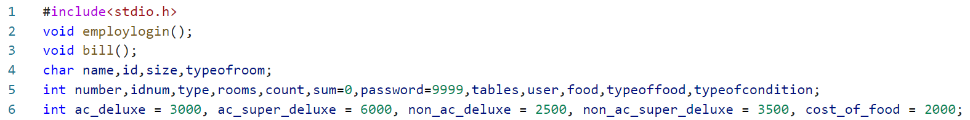

fg(i)

🡪Declaration of global variables and sub functions related to rates and type of rooms and type of food etc.

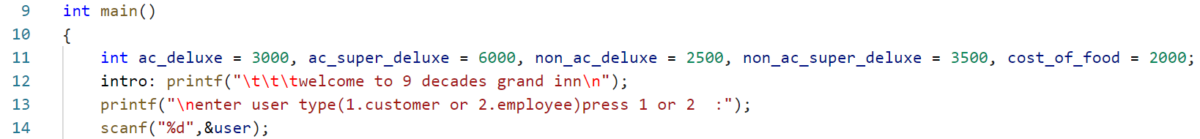

fg(ii)

🡪“Intro” is the label for goto statement if the goto statement added to function then the control transfer to intro

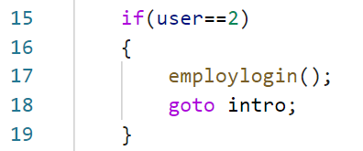

Fg(iii)

🡪From the user input program splits into two categories one is customer and employeeBy input 1 and 2 here conditional statements shift the control to user type.

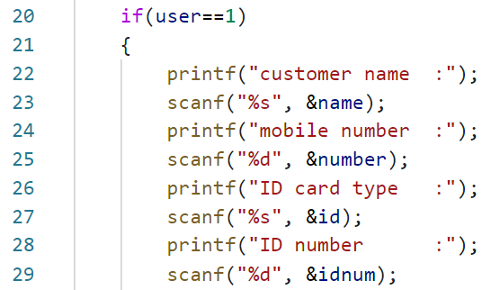

Fg(iv)

🡪The if statement allows you to control if a program enters a section of code or not based on whether a given condition is true or false. ... One of the important functions of the if statement is that it allows the program to select an action based upon the user's input.

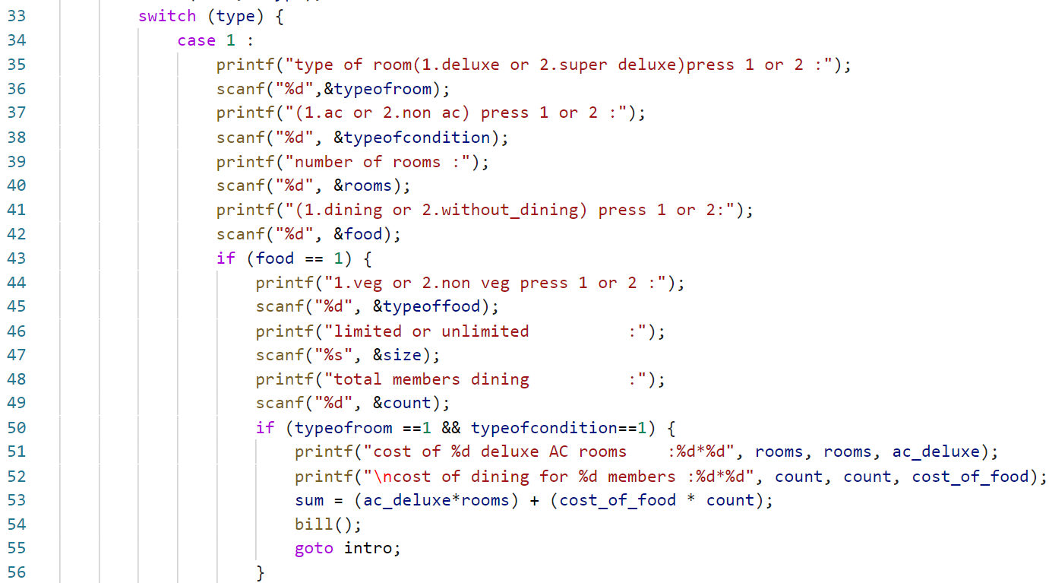

Fg(v)

🡪(Each value is called a case, and the variable being switched on is checked for each switch case.)

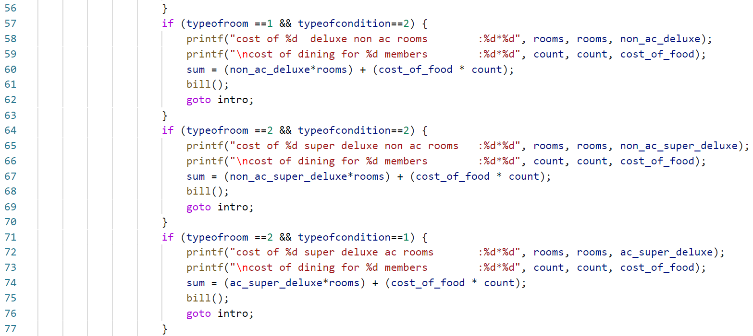

Fg(vi)

🡪In switch case 1 this includes price for selected choice like each conditional statements consists of different combinations of customer selections of dining and lodging .

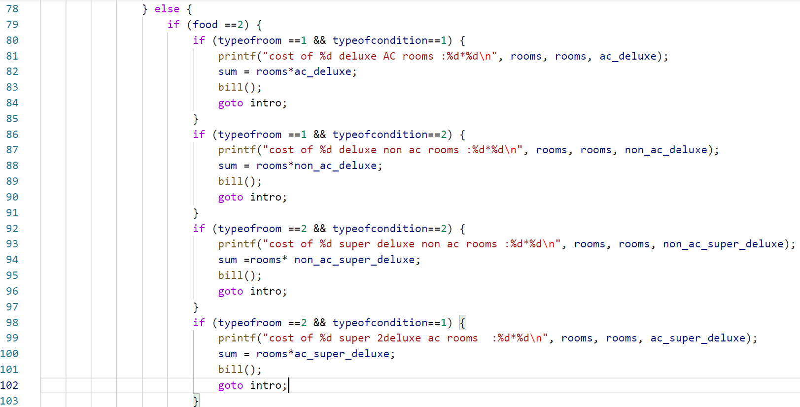

Fg(vii)

🡪Else conditional statements consists of nested if to give combinations of prices of user selection of only lodging.

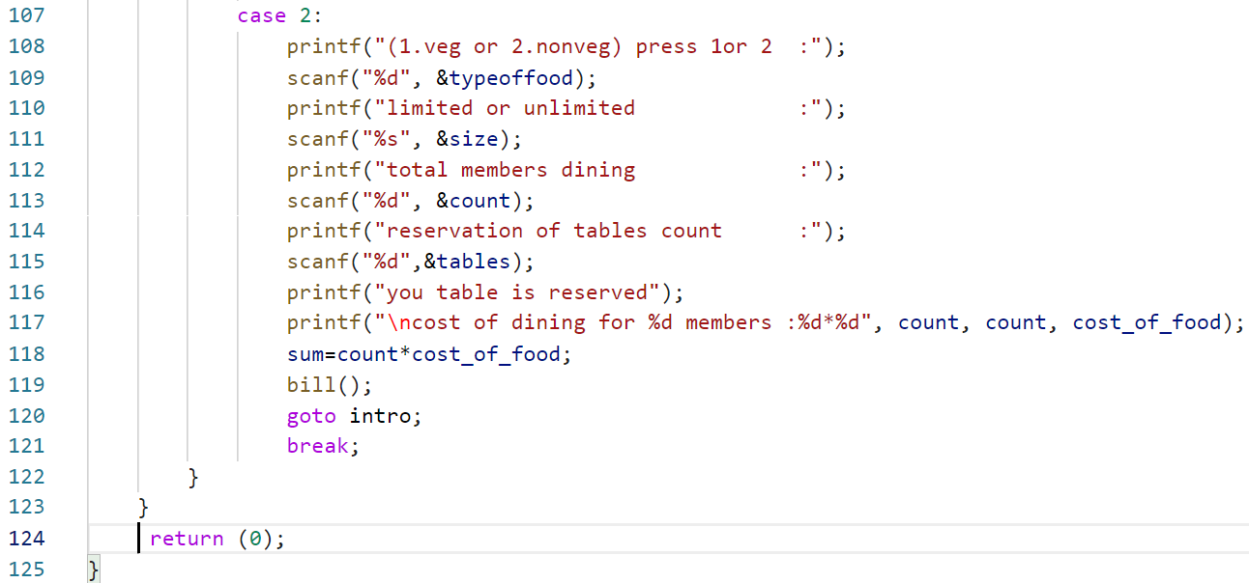

Fg(viii)

🡪In this module switch case 2 consists of customer input related to only dining facility here, the prices even be displayed in bill subfunctions.

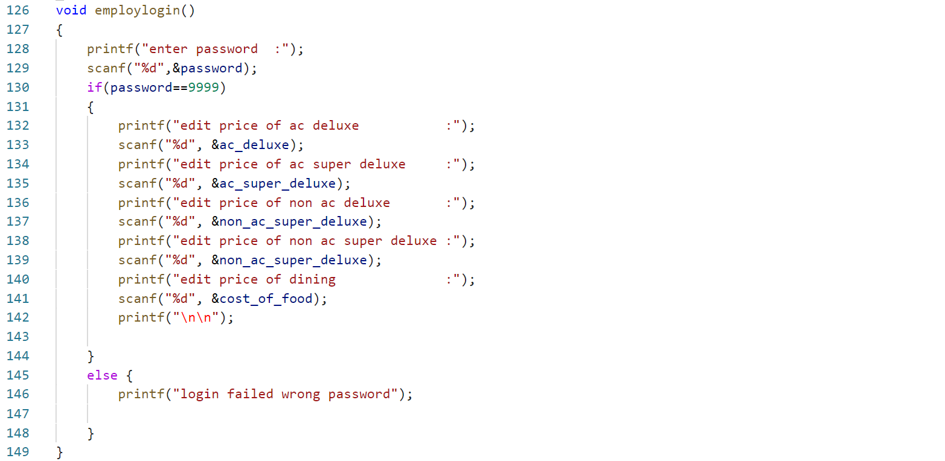

Fg(ix)

🡪Here employlogin () is subfunction consists of user input related rate fixation of different categories of customer selection.

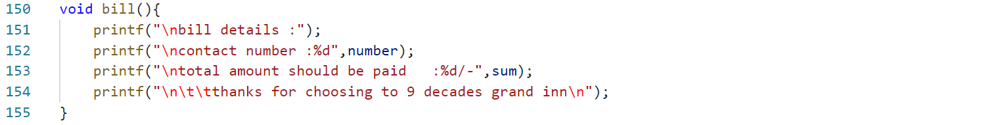

Fg(x)

🡪Here bill () is totally a output subfunction which consists of bill details like amount to be paid.

The function is used in all conditional statements and even in swich cases it’s a important function in this project.

CHAPTER: 07

**RESULTS**

**RESULTS FOR VARIOUS INPUTS BY USER**

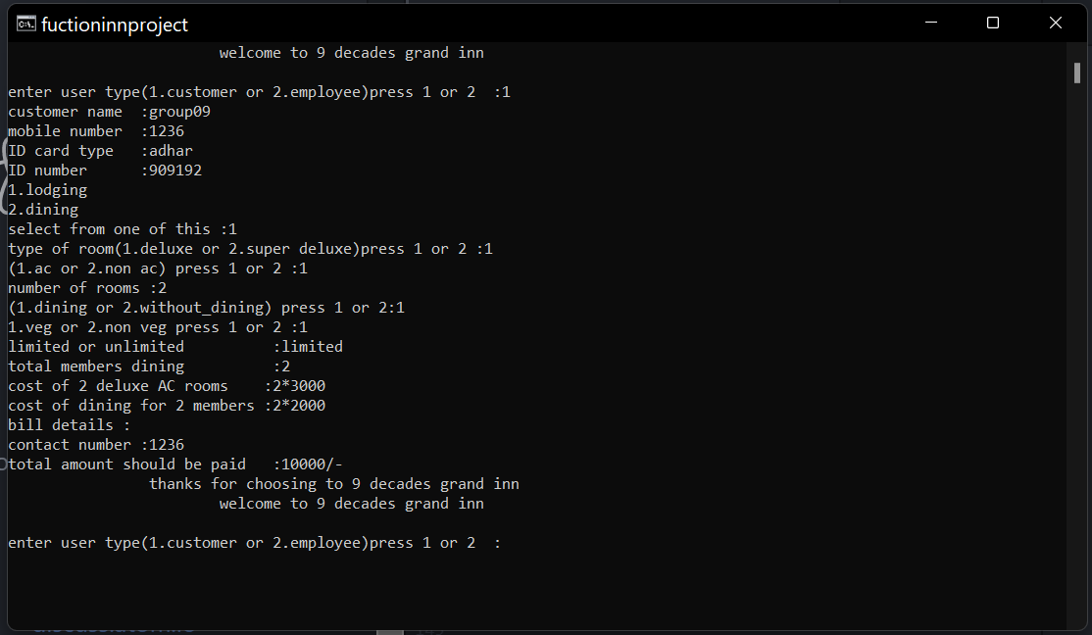

**Rfg(i)**

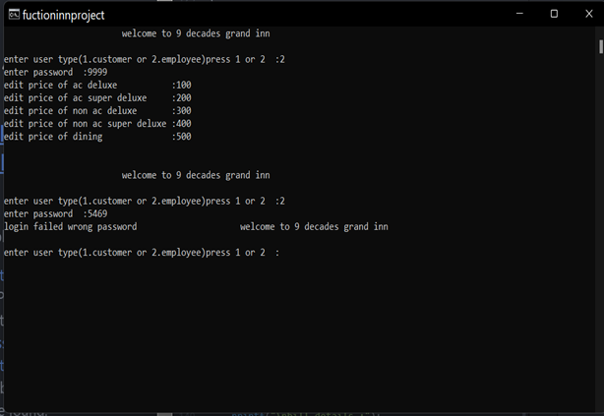 **When user ==1 (customer selecting both dining and lodging )**

**Rfg(ii)**

**When user==2 (employee ) user editing the prizes**

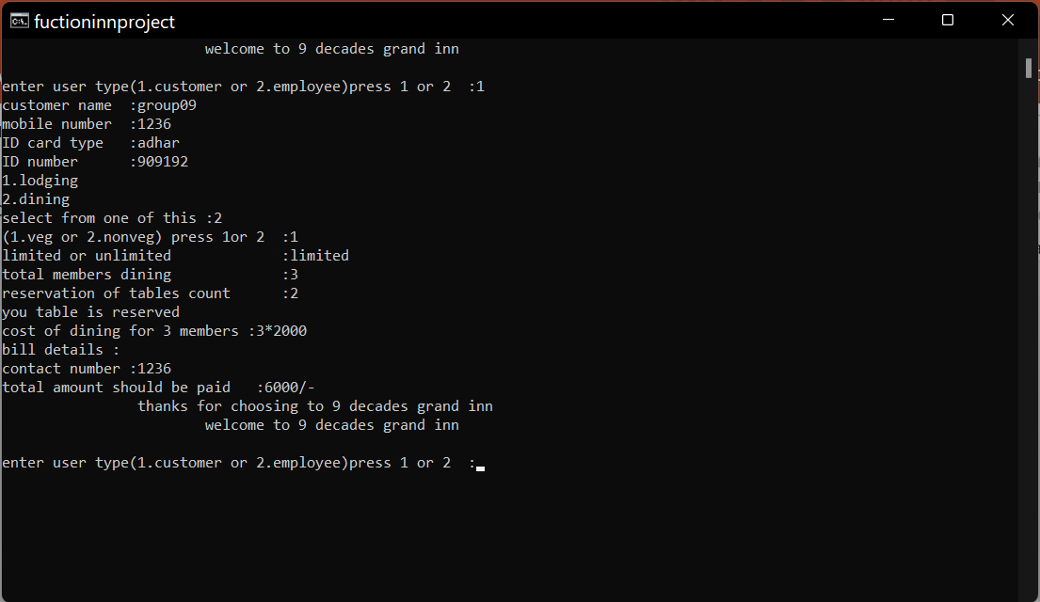

**Rfg(iii)**

**When user==1 (customer) selected dining**

**-----------THE END-----------**